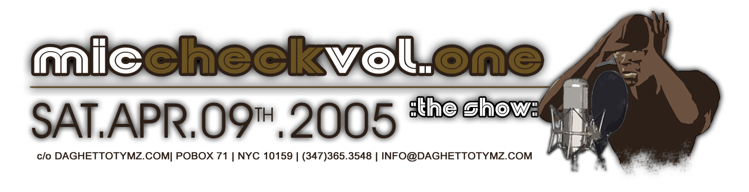
2005 DA GHETTO TYMZ MAGAZINE(c)
MICCHECK VOL.ONE INTERACTIVE CD PROJECT®

* READ ME *

---------------------------------
Starting the
MicCheck Vol.One Interactive CD Project
---------------------------------
Before you begin your journey through our DGT MicCheck Vol.One Interactive CD Project®, we advise you to update your web-browser (Internet Explorer, Netscape Navigator, Mozilla, Safari) to the latest versions. To get the updates, simply go to their sites.

We recommend you view your DGT MicCheck Vol.One Interactive CD Project® in Internet Explorer 6+, Mozilla Firefox or Nestcape Navigator 7+.

As a convenience for your monitor size, we've created 3 monitor settings to choose from. Insert the CD into your computer, double-click on the ‘MicCheck Interactive CD’ CD and click one of the following:

(1) "main.html" (800 x 600)
(2) "mainsmall.html" (640 x 480)
(3) "mainlg.html" (100% browser size)

For maximum speed, copy the CD folder to your harddrive and play off your harddrive.
---------------------------------
Ownership
---------------------------------
This CD contains material created, written, designed, produced and published by Da Ghetto Tymz magazine's(c), DGT D'Zynz Studios, a subsidiary of DGT Communicashunz, Inc. All Rights Reserved.

---------------------------------
System Requirements
---------------------------------
For Macintosh OS
• System 9.0 or greater (preferably OSX+)
• 10+ MB RAM and 15+ MB free hard-drive space
• 8-bit color display or greater
• CD-ROM drive

For Windows OS
• Windows XP, Windows NT or Windows 2000
• 10+ MB RAM and 15+ MB free hard-drive space
• 8-bit color display or greater and graphics card
• CD-ROM drive

---------------------------------
Compatibility Issues
---------------------------------
This CD contains material that can be read using a PC or Apple MacIntosh (Mac) computer. The files require free updated software.

To Read DGT Back Issues (.pdf files):
Adobe Acrobat Reader - Can be read on practically any version 4.0 and up. For the latest free download, simply go to (cut and paste in browser address box) http://www.adobe.com/products/acrobat/readstep2.html for a free download. This download will take approximately 1-2 minutes.

To Read Interactive CD Project (.swf files):
Macromedia Flash Player – Along with the Interactive CD Project being made in Macromedia Flash, as a special bonus, for your enjoyment we've attached DGT Trailers that gives you an animated look at some of the many products Black-owned business vendors at our event, ‘MicCheck Vol.One,’ have available. This can be read on practically any version of Macromedia Flash Player 5.0 and up, however, to ensure the capability of viewing its full functionality, we suggest you get the free download of the latest Macromedia Flash Player.

For the latest free download, simply go to (cut and paste in browser address box) http://www.macromedia.com/shockwave/download/index.cgi?P1_Prod_Version=ShockwaveFlash for a free download. This download will take approximately 1-2 minutes.

---------------------------------
Contact Info.
---------------------------------
For further inquiries,
Da Ghetto Tymz magazine
DGT D’Zynz Studios
POBox 71
New York, NY 10159
(347)365.3548
info@daghettotymz.com
www.daghettotymz.com

---------------------------------
Copyright (c) 1993-2005 Da Ghetto Tymz magazine. All Rights Reserved.

